Trip-Based Model Installation Instructions  
(only required once per user, per modeling server)

1. Start by installing [Anaconda 64bit Python 3](https://www.anaconda.com/distribution/) on the server you will be using (if you haven’t already). When you go through the installation setup:
   * Install: **Just me**
   * Do **NOT** add to PATH environment variable
2. Now use the Anaconda Prompt to clone the cmap_trip-based_model GitHub repo – open the prompt

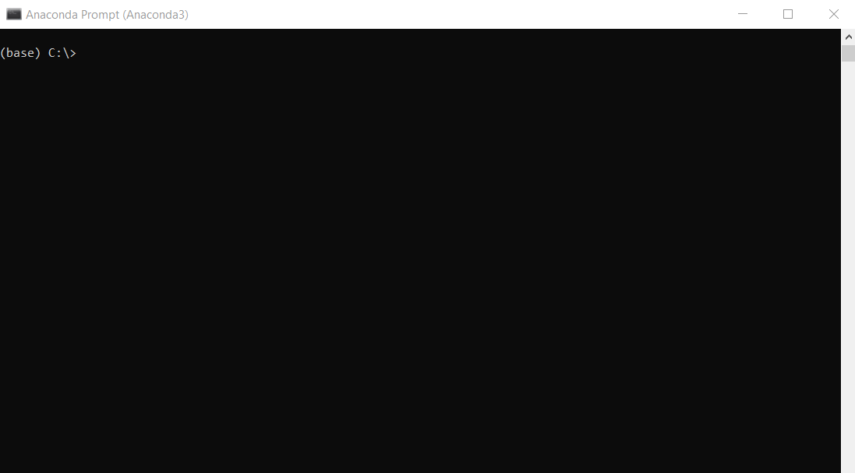

1. Next install git. Enter the following in the Anaconda prompt:

>conda install –-channel conda-forge git

1. Next clone the CMAP trip-based model code from GitHub
   * I suggest creating a folder for this (like C:\Users\<username>\TBM). Create the folder and navigate there in Anaconda Prompt:  
     >cd C:\Users\<username>\TBM
   * Clone the repo – enter the following command in the Anaconda Prompt:  
     >git clone https://github.com/camsys/cmap_trip-based_model.git
   * Move into the repo and checkout a branch — ‘master’ (default) for the most recently approved version of the model or ‘develop’ for the version of the model with the most recent changes:  
     >cd cmap_trip-based_model  
     and either  
     >git checkout master  
     or  
     >git checkout develop
2. Next, create a conda environment to use for the mode, destination and time-of-day model components, which are written in Python. Creating a unique environment will ensure that all the necessary computational libraries are installed, and no conflicts are introduced with other tools (including Emme). A conda environment file is included in the GitHub repository, which installs everything you need into an environment called "CMAP-TRIP”. Enter the following in the Anaconda prompt:  
   >conda env create --file src/Mode-Dest-TOD/conda-environment.yml
3. This should have created the “CMAP-TRIP” environment in your User folder and contains all of the libraries needed to run the model.

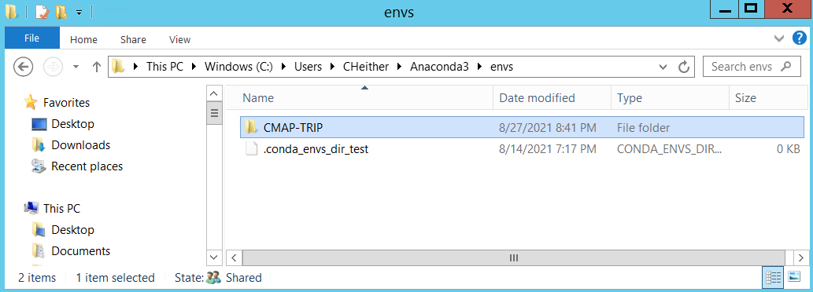

1. The model is now installed and located in the folder created in step 4. Use [these instructions](full_travel_demand_model_run_steps_c23q2.docx) to set up a scenario and run it.